Project name | Insert project name here | Briefed by | Insert name here
Project number | Insert project number here | Date | Insert date here
Department/agency | Insert cost centre here | Contact details | Insert phone/ email here
P.O# / 4 Digit Code | Insert PO or <$250k code | Creative agency | Insert creative agency here
Budget | Specify incl./excl. fees + gst | Campaign Live Date – Finish Date | Insert campaign timings here
All NSW Government agencies must consider the needs of regional and rural NSW communities in their media planning:
- Allocate at least 26% of campaign media expenditure to reach regional communities.
- Media expenditure to reach regional communities should include independent and local print media advertising.
- From the 26% regional media budget allocation, ensure 10-20% is allocated to regional print.
- For campaigns over $250,000, agencies must account for their expenditure and ensure that it meets regional reach requirements.
All NSW Government agencies must consider the needs of multicultural and First Nations communities in their media planning:
- From July, 2024 at least 9% of an advertising campaign media budget is to be spent on direct communications to multicultural and Aboriginal audiences.
- Spend may be on advertising (paid media) or non-advertising communications activities (e.g., events, public relations).
- Spend under the policy does not include the costs for creative, production of paid media assets, translation, or research.
Please find more information about how to apply this policy on the NSW Government website.

Tiering qualifiers
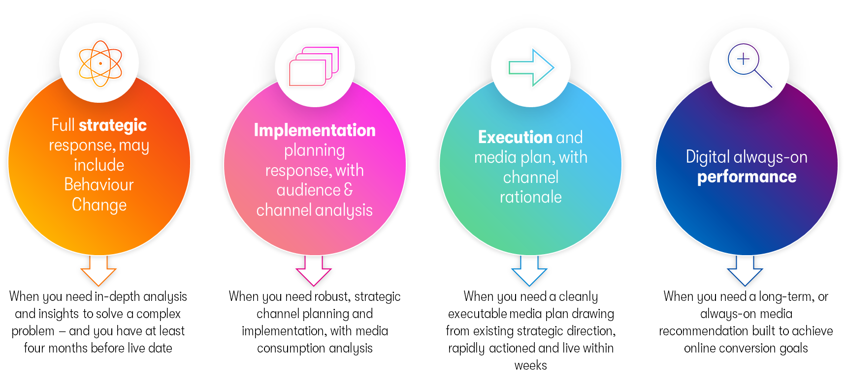

Please mark which tier your brief sits in based upon the following criteria, noting only ONE tier can be selected.

Strategic  +4 months | Implementation  + 2 months | Execution  + 3 weeks | Digital  + 2 months

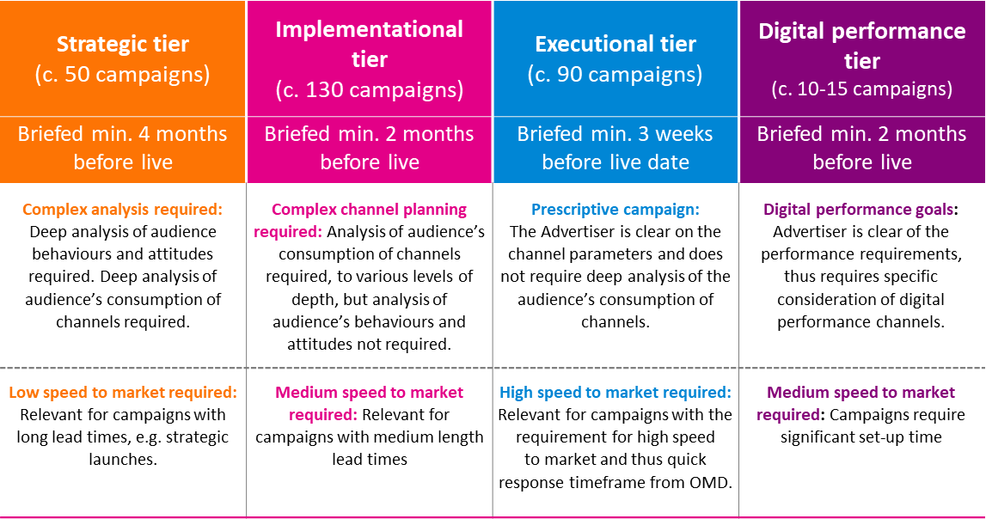

Decision makers  Insert name here | Stakeholders  Insert name here

Critical problem
Strategic market brief background. What are we trying to help solve with this advertising?What is the behaviour change we’re trying to drive?
Enter here
Objectives
What are the key goals for this campaign?  Enter here | What are the measures of success / key metrics?  Enter here
Marketing and communications task
What do we want our audience to know, intend and/or do as a result of this campaign?
Enter here
Communications approach
Are we looking for big ideas, media partnerships, socially enhanced activities, something to cut-through: shock or engage, content, broadcast initiative, experiential etc.?
Enter here
Deliverables
What do we (OMD) need to deliver in order to achieve results?
Enter here
Target audience
Who are we trying to influence? Describe them in terms of demographics, attitudes, size, beliefs and behaviour.  Enter here |  | What are the key barriers for our audience?  What and who influences their choices?  Enter here
Who are the multicultural and Aboriginal audiences?  First Nations audiences:  ☐ Aboriginal and Torres Strait Islander peoples  Multicultural audiences, spoken languages:  ☐ Mandarin ☐ Arabic ☐ Cantonese ☐ Vietnamese ☐Hindi  ☐Greek ☐Spanish ☐Nepali ☐Italian ☐Korean  Other languages (if any): |  | Please specify the reason if the campaign is not meeting the 9% policy requirement.  Enter here
Insight/s
What is/are the customer insight/s that drive this brief? Please provide any relevant research or information you have on the behavioural change you are looking to drive.
Enter here
Stages of Change/ Journey
Where in the stages of change/logic model path are we intersecting and influencing our target?
Enter here
Key messages
What are the key messages to be communicated and measured?
Enter here
Creative assets
Are there existing assets that could or should be used as part of this brief?
What creative executions are/will be available? How many different creative executions are being planned? If the execution is new, when will it be ready? Will the creative change during the campaign? Please provide details.
Enter here
Paid, owned, and earned
Please advise if there is any existing paid activity or earned program of work. What owned assets are available for this campaign (website, signage etc.?)
Enter here
Measurement
Is it website traffic, audience reach, social followers, video views?
KPIs to be included subject to campaign idea.
Enter here
Regions / markets |  | Creative agency
In order of priority  Enter here |  | Who is developing the creative assets?  Enter here
Timings |  | Budget
Enter here |  | Enter here
Mandatories
List any mandatory activity requirements for this brief i.e. TV must be included, social media campaign, content development. Or list what needs to be avoided: no viral video, etc.
Enter here
Do you require OMD Diverse team translation services?
Enter here

Any other relevant information?
Enter here

The DCS Brand and Communications team can provide advertising services support for this brief/your campaign, including in multicultural and Aboriginal audiences, digital, and advertising best practice. Reach out to diversecomms@customerservice.nsw.gov.au; digitalcampaigns@customerservice.nsw.gov.au;
adreviews@customerservice.nsw.gov.au"

